**PROJECT TITLE:** (Comprehensive digital marketing for plum goodness)

**STUDENT NAME**: P. MUNEER

**PROJECT SUPERVISOR**: SREENIVASULU

**DEPARTMENT**: COMMERCE

**COLLEGE**: B.T GOVT DEGREE COLLEGE

**Team ID:** LTVIP2025TMID19525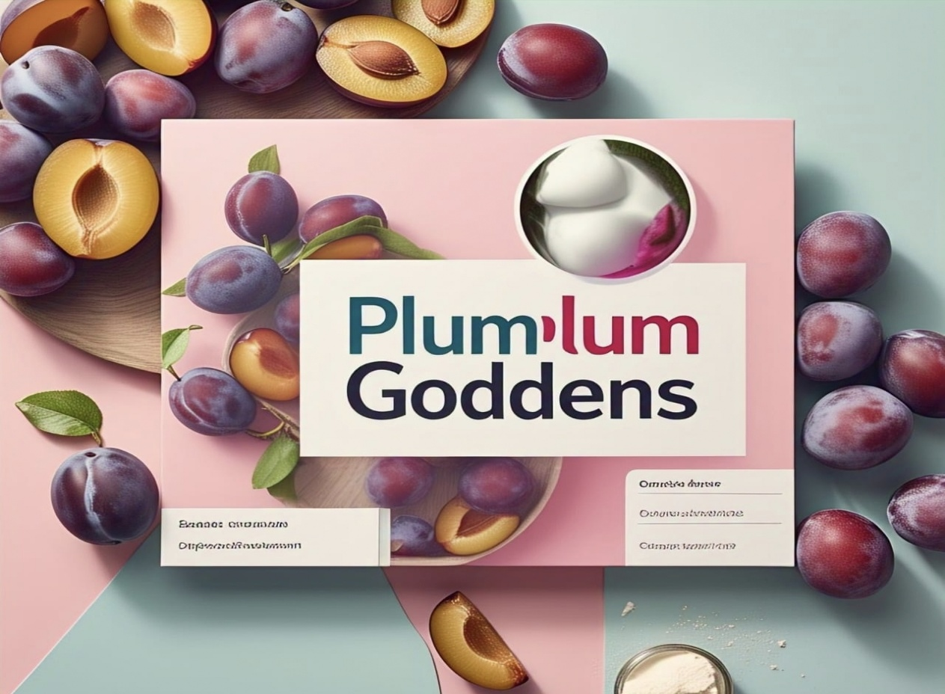

**INTRODUCTION**

In today's digital-first beauty landscape, Plum Goodness aims to solidify its position as a leading natural and organic skincare brand. To achieve this goal, a comprehensive digital marketing strategy is essential. This approach will enable Plum Goodness to effectively reach and engage with its target audience, drive website traffic, boost sales, and build a loyal community of customers and advocates. By leveraging the power of digital marketing, Plum Goodness can increase brand awareness, reinforce its unique value proposition, and ultimately, drive business growth.

**Brand Foundation, Competitor lights, and Target Persona**

The Brand Foundation of Plum Goodness’ represents the essence of the brand—its purpose is to provide natural, vegan, and cruelty-free skincare that is effective and eco-friendly. It values sustainability, transparency, and self-care, and promises high-quality skincare products that nurture and care for the skin.

* Brand Identity Research:-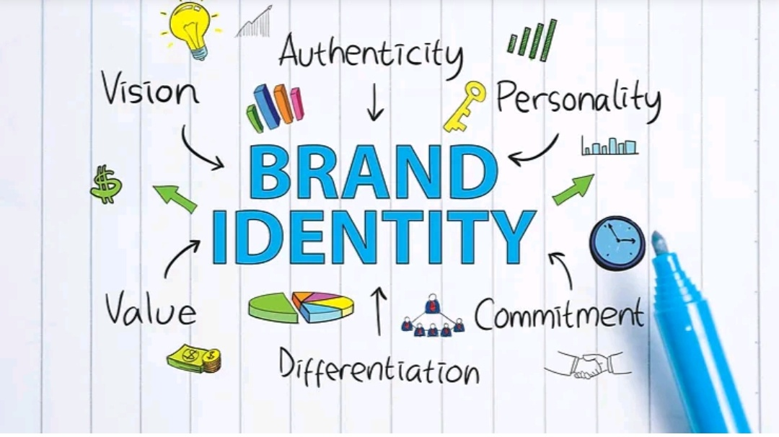

A deep cive into Plum Goodness existing brand identity: We aim to uncover its core values, mission, and unique selling propositions. This research will inform all subsequent marketing efforts, ensuring brand consistency and authenticity

* Competitor Analysis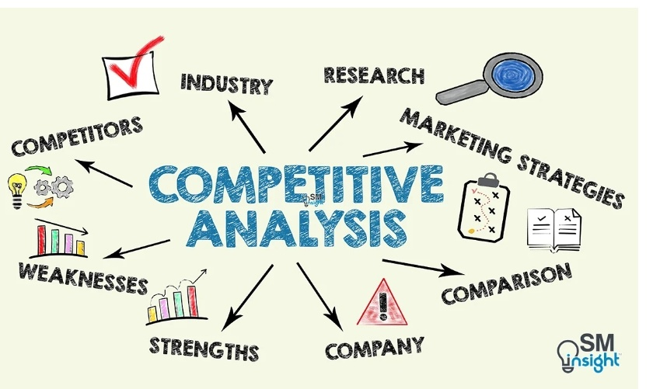

A thorough examination of key competitors in the skincare market. We will analyze their strengths, weaknesses, online strategies, and customer engagement tactics to identify opportunities for Plum Goodness to stand out.

* Buyer Persona Development



Crafting detailed profiles of Plum Goodness ideal customers. These personas will encompass demographics, psychographics, online behavior, and purchasing habits Understanding the target audience is key for tailored marketing campaigns

**SEO Optimization & Strategic Keyword Research**

Plum Goodness's SEO optimization and strategic keyword research involve identifying relevant keywords and phrases that align with the brand's products and services.

1 Comprehensive SEO Audit



A technical SEO audit to identify and rectify website issues Affecting search enginrankings. This includes analyzing site structure, mobile-friendliness page speed, and other factors critical for optimal performance

**2 Targeted Keyword Research**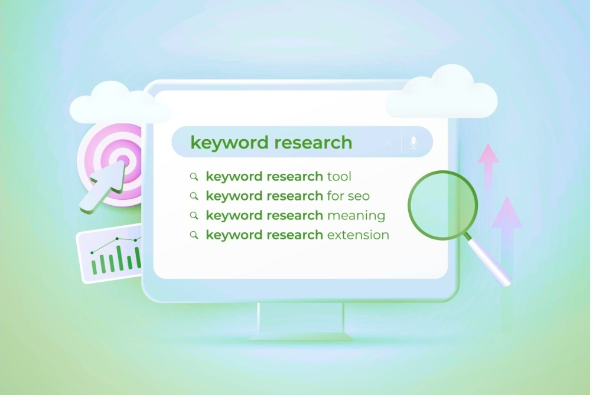

In-depth keyword research to identify high-value search terms relevant to Plum Goodness products and target audience. This research will drive content creation and on-page optimization efforts, ensuring maximum visibility in search results

3 On-Page Optimization

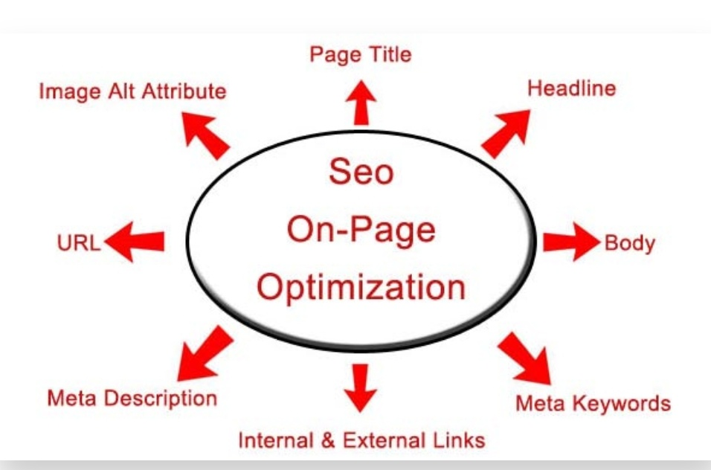

Strategic implementation of targeted keywords and optimization techniques on website content, meta descriptions, and image alt tags This will improve Plum Goodness search engine rankings and attract more organic traffic.

**Innovative Content and Marketing Strategies**

Plum Goodness can leverage innovative content and marketing strategies to connect with its target audience, increase brand awareness, and drive sales. Here are some ideas:

* Content idea for generation



Plum Goodness can create content around the effectiveness of its natural ingredients, like green tea and Vitamin C, in targeting specific skin concerns such as acne or pigmentation. Highlighting their eco-friendly, vegan, and cruelty-free practices can also resonate with eco-conscious consumers.

* Strategic Content Marketing

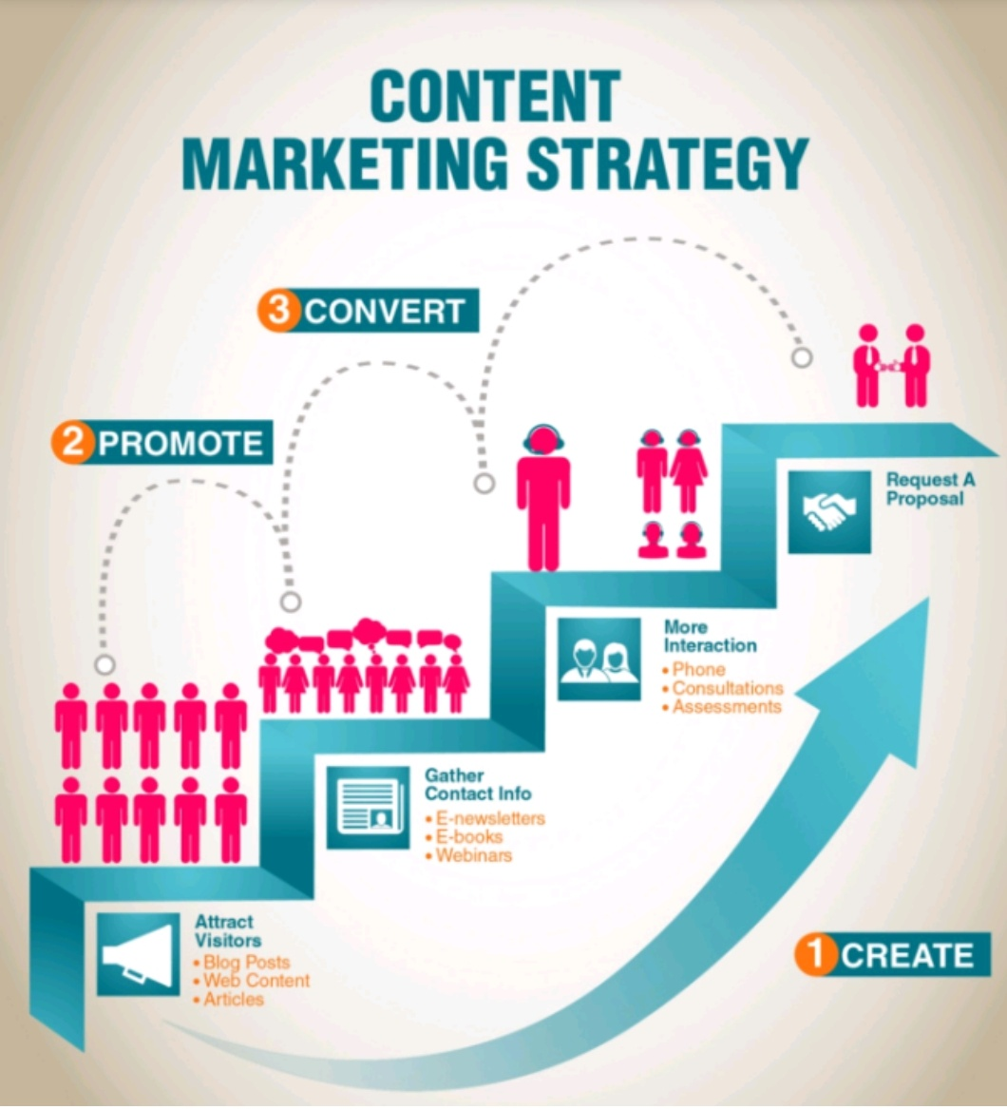

Developing a comprehensive content marketing strategy aligned with Plum Goodness business goals. This strategy will outline content themes, publishing schedules distribution channels, and metrics for measuring success

* Holistic Marketing Strategies



Designing marketing strategies that leverage content to enhance marketing performance Creating social media posts, videos, and other engaging content. This will maximize reach, drive website traffic, and generate leads

**Content Creation and Campaign Execution**

Experience the vibrant and refreshing essence of ‘plum goodness’ in every bite of our product. With its rich, natural flavour’s and a burst of freshness, our offering promises to bring a touch of indulgence to your daily routine

* Engaging Post Creation

Crafting high-quality, visually appealing posts for various social media platforms. These posts will showcase Plum Goodness’ products, brand values, and customer testimonials, creating a strong online presence

* Design and Video Editing

Creating visually stunning designs and editing compelling videos to capture the attention of the target audience. This includes product photography, graphic design, and video production services

* Social Media Ad Campaigns

Developing and executing targeted social media advertising campaigns to reach a wider audience and drive conversions. These campaigns will leverage platform-specific targeting options and compelling ad creatives

* Email Marketing Campaigns

Designing and implementing email marketing campaigns to nurture leads, promote products, and build customer loyalty. These campaigns will include personalized email sequences, product announcements, and exclusive offers.

**CONCLUSION**



Plum Goodness is a skincare brand that offers natural, eco-friendly, and vegan skincare products, resonating with eco-conscious consumers. The brand’s commitment to sustainability and cruelty-free practices sets it apart, and by creating engaging content and executing strategic campaigns, Plum Goodness can effectively reach and retain its target audience, driving business growth and brand loyalty.